Unstructured Database Lab 23.03.2026 | studio 3T
Database: college_student
Collection: students
Insertion:
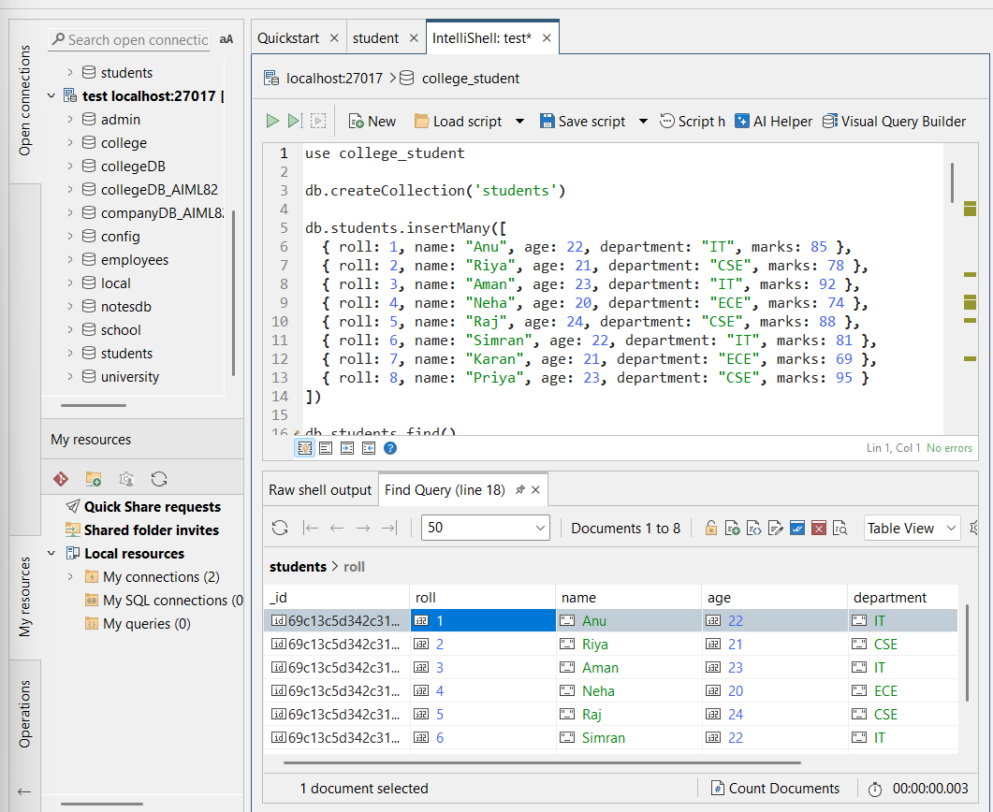

Q1. Display all documents
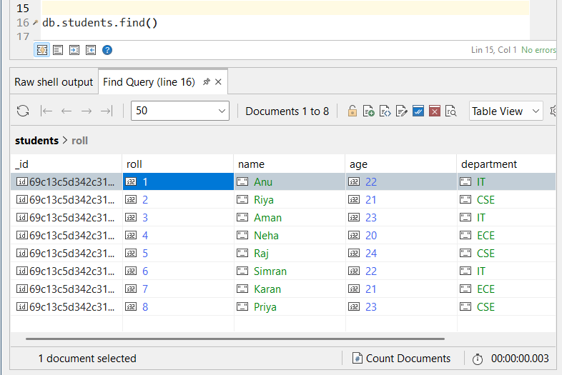
Q2. Find students from IT department
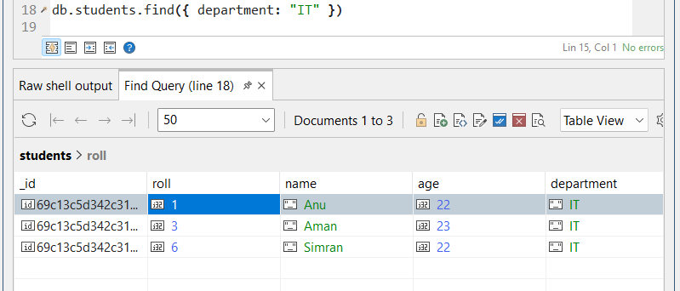

Q3. Find students with marks > 80
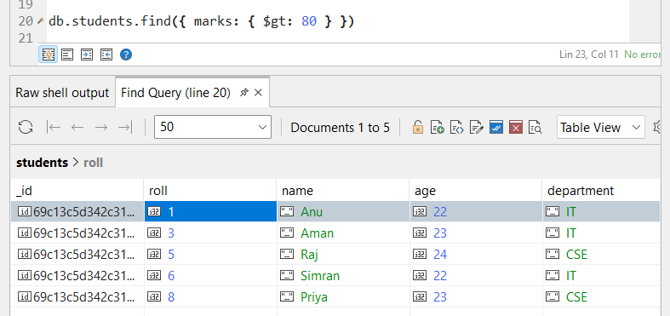
Q4. Insert one new student
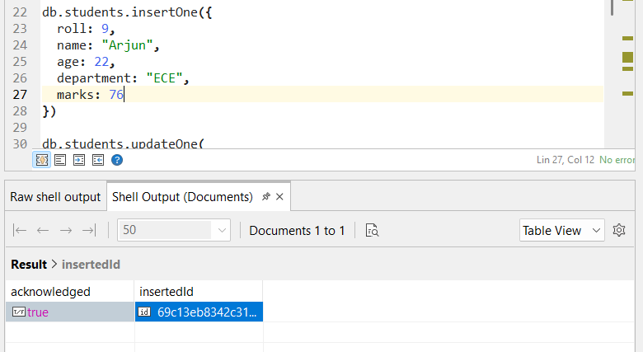

Q5. Update marks of Anu to 90
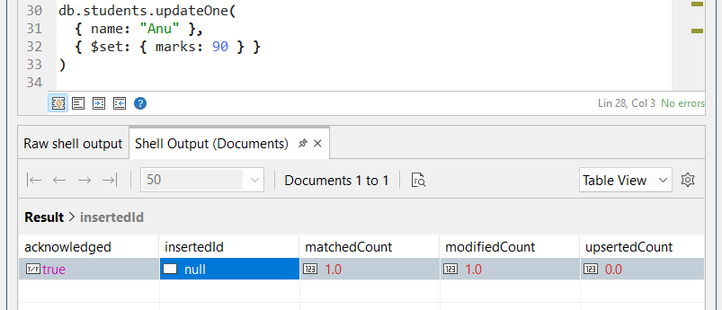
Q6. Add a new field "status: Pass" for all students
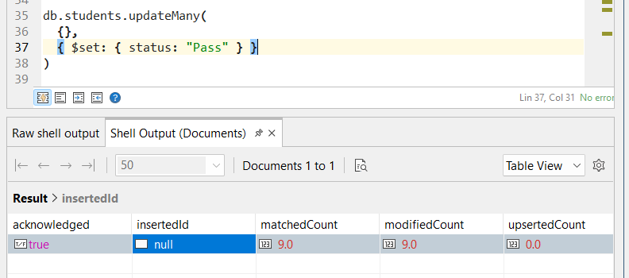

Q7. Delete all students with marks < 70
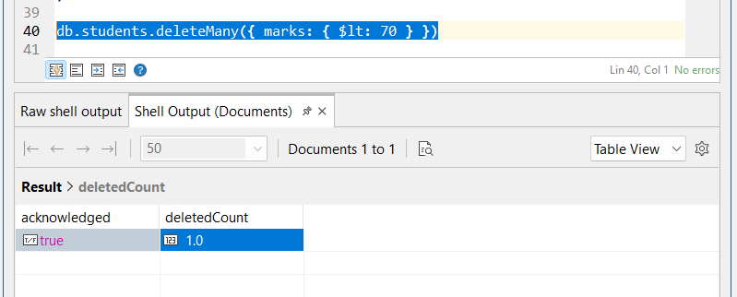
Q8. Count students in CSE department
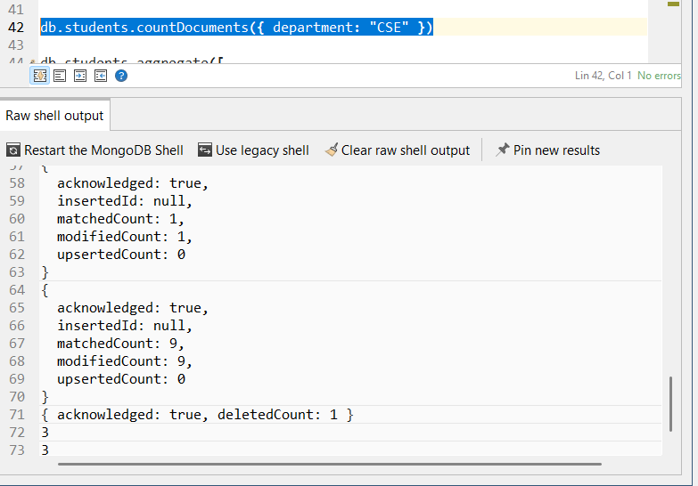

Q9. Find total students in each department
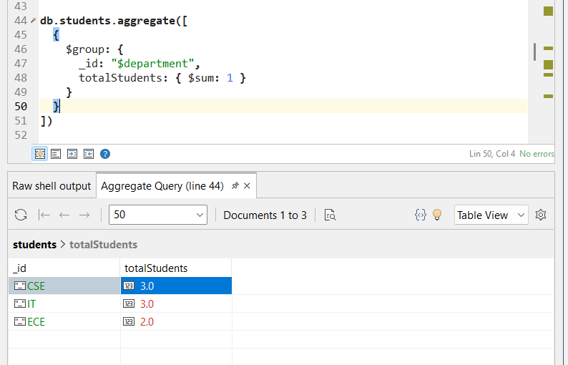
Q10. Find highest marks
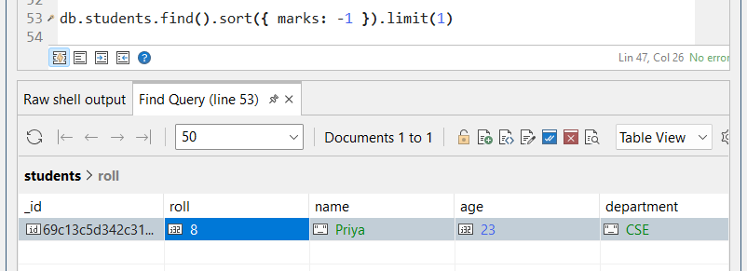

Q11. Find the second highest marks
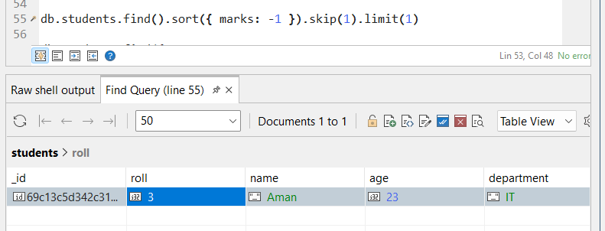
Q12. Find students whose name starts with 'A' and marks > 80
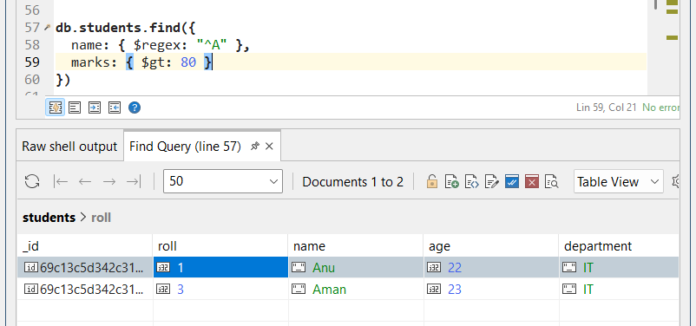

Q13. Display department-wise average marks, only for departments where avg > 80
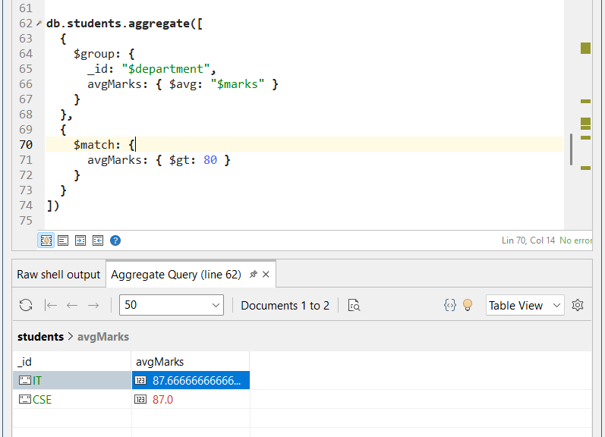

Q14. Find students with marks between 75 and 90, sorted by marks ascending
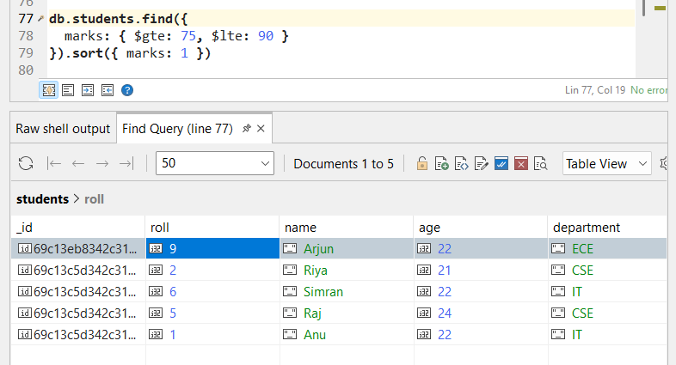

Q15. Add grade field based on marks
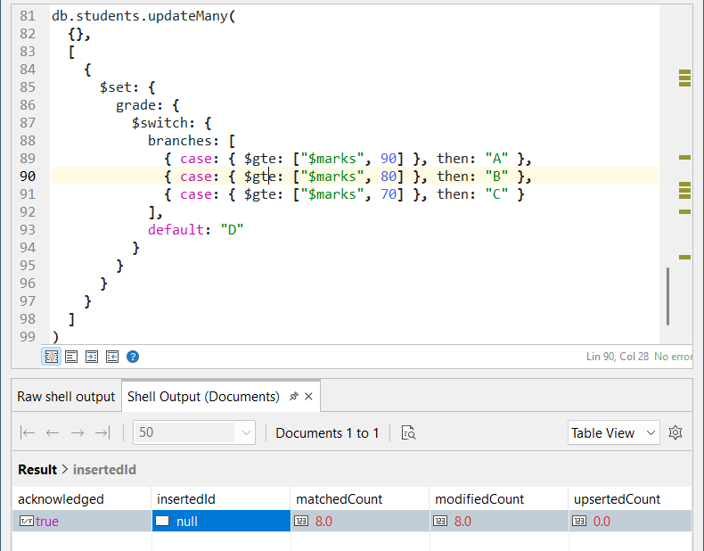
All queries:
use college_student

db.createCollection('students')

db.students.insertMany([
{ roll: 1, name: "Anu", age: 22, department: "IT", marks: 85 },
{ roll: 2, name: "Riya", age: 21, department: "CSE", marks: 78 },
{ roll: 3, name: "Aman", age: 23, department: "IT", marks: 92 },
{ roll: 4, name: "Neha", age: 20, department: "ECE", marks: 74 },
{ roll: 5, name: "Raj", age: 24, department: "CSE", marks: 88 },
{ roll: 6, name: "Simran", age: 22, department: "IT", marks: 81 },
{ roll: 7, name: "Karan", age: 21, department: "ECE", marks: 69 },
{ roll: 8, name: "Priya", age: 23, department: "CSE", marks: 95 }
])

db.students.find()

db.students.find({ department: "IT" })

db.students.find({ marks: { $gt: 80 } })

db.students.insertOne({
roll: 9,
name: "Arjun",
age: 22,
department: "ECE",
marks: 76
})

db.students.updateOne(
{ name: "Anu" },
{ $set: { marks: 90 } }
)

db.students.updateMany(
{},
{ $set: { status: "Pass" } }
)

db.students.deleteMany({ marks: { $lt: 70 } })

db.students.countDocuments({ department: "CSE" })

db.students.aggregate([
{
$group: {
_id: "$department",
totalStudents: { $sum: 1 }
}
}
])

db.students.find().sort({ marks: -1 }).limit(1)

db.students.find().sort({ marks: -1 }).skip(1).limit(1)

db.students.find({
name: { $regex: "^A" },
marks: { $gt: 80 }
})

db.students.aggregate([
{
$group: {
_id: "$department",
avgMarks: { $avg: "$marks" }
}
},
{
$match: {
avgMarks: { $gt: 80 }
}
}
])

db.students.find({
marks: { $gte: 75, $lte: 90 }
}).sort({ marks: 1 })

db.students.updateMany(
{},
[
{
$set: {
grade: {
$switch: {
branches: [
{ case: { $gte: ["$marks", 90] }, then: "A" },
{ case: { $gte: ["$marks", 80] }, then: "B" },
{ case: { $gte: ["$marks", 70] }, then: "C" }
],
default: "D"
}
}
}
}
]
)

